Costa Rica is a very well educated country; part of this is because of all the funding that they put into the school and education programs. The country has a lot of funding because they are one of the few countries in the world that does not have a military. They are one of the most successful countries that are able to live without a military, they are right behind Japan in that aspect. They are meeting the initiatives of the United Nations and are very successful because of the three initiatives. The school programs are well funded by the government, which helps equip the classrooms with all the school supplies that they need. They are also able to hire more teachers per classroom with these budgets so there are not too many students in each class for the teachers to not be able to handle an entire classroom. The education funds from the GDP of the country are a minimum of eight percent each year. In Central America a large amount people who are successfully educated are from Costa Rica, they have one of the best education systems in Central America and South America. The Secretary General of the United Nations, Ban Ki-moon, stated “I call on world leaders and all involved with education to join this initiative and fulfill the promise to make quality education available to all children, young people and adults. Together, we can empower individuals to transform our world” (An Initiative of the Secretary-General).
Following the first initiative by the United Nations, that every child needs to be educated in school, Costa Rica has a law that every person must have some sort of an education. There are very high literacy rates in the country, and ninety eight percent of the children in the country between ages of fifteen and twenty-four are literate. Costa Rica also has many programs in the schools for people to learn English, and dealing with technology innovation. These programs help people when it comes to working internationally. There is about eighty five percent of students in Costa Rica that go to English classes when they are young. After elementary school, which is from the ages six to thirteen, students have two options on where to go after their elementary school. The choices for the students are academic and technical school, they are able to receive a high school diploma with either schooling choice that they decide to go to. After going to academic school or technical school they are able to then go on and attend more schools as in a university (An Initiative of the Secretary-General).
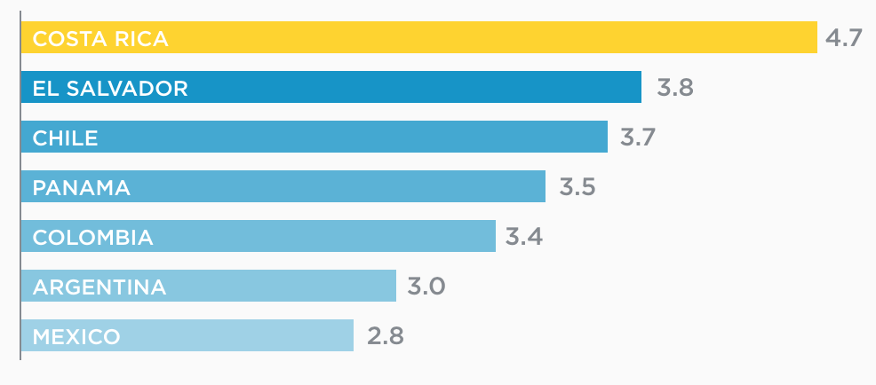
(The Investment Promotion Agency of Costa Rica)
The secondary schools in Costa Rica, both academic and technical, follow the second initiative from the United Nations, which states that there needs to be improvements in the quality of the education of students. Both of these schooling options help prepare students for their future endeavors in life. Students are taught the basics of careers, good work ethics, basic business tips and many more life skills that will benefit them in their adulthood. These schools better prepare them to go to universities and colleges where they become even better prepared for their futures. There are many people who go to the universities in the countries, so it is harder for people to get jobs in the country because there is an extremely competitive field when it comes to getting a job (An Initiative of the Secretary-General).
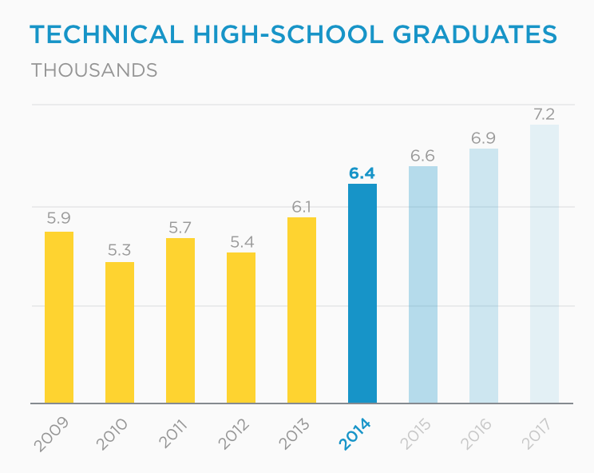

(The Investment Promotion Agency of Costa Rica)
The third initiative by the United Nations is made very present in Costa Rica; fostering global citizenship. It is important for education to help shape student’s futures. Education should also help bring respect and peace throughout the countries in the world. There is mutual respect for people in Costa Rica with other countries. There are schools in Costa Rica that are for students who speak different languages because they are from different countries. Most of these schools are private schools; they speak the Costa Rican language of Spanish along with their first languages. Most of the students that go to these schools are from the United States, the United Kingdom, France, Germany, Israel, and many other schools. Costa Rica schools are also able to remain peaceful with the equality that they represent in the schools from all races and equality between genders. Women in the country tend to be more literate than the men do (An Initiative of the Secretary-General).
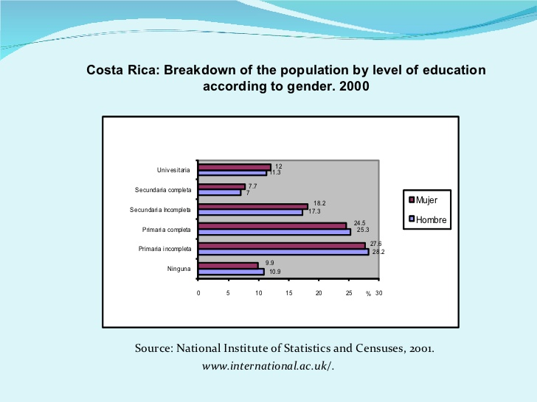
(Gender Equality in Costa Rica)
References
An Initiative of the Secretary-General. (n.d.). Retrieved April 08, 2016, from http://www.globaleducationfirst.org/289.htm
Education in Costa Rica. (n.d.). Retrieved April 08, 2016, from https://www.internations.org/costa-rica-expats/guide/living-in-costa-rica-15466/education-in-costa-rica-2
Gender equality in costa rica. (n.d.). Retrieved April 08, 2016, from http://www.slideshare.net/19632110/gender-equality-in-costa-rica-8619194
The Investment Promotion Agency of Costa Rica. (n.d.). Retrieved April 08, 2016, from http://www.cinde.org/en/why

